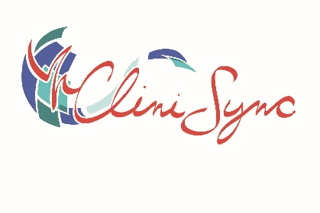
CliniSync: Notify Build Form

Project Information (Please complete)

Organization Name
Site Administrator(s)
Site Administrator Phone
Site Administrator Email
Estimated size of Patient Panel

How Will Your Organization Receive Notifications
(Check the delivery method(s) that will apply to your organization.)

Web Portal Only | ☐ | Notifications are accessible through the Notify web portal
Direct Secure Email | ☐ | Notifications are sent to a secure email address that must be either approved or provisioned by CliniSync. Patient data is available in the message.  Direct Secure Email Frequency  Immediately ☐  Daily ☐ Please specify time:  Weekly ☐ Please specify the day & time:  Bi-weekly ☐ Please specify the day & time:  Monthly ☐ Please specify first, 15th, or last day of the month & time:
sFTP Delivery | ☐ | Notifications are sent to an sFTP site through a delivery agent provisioned by CliniSync in the form of HL7 flat files.

Which Notification/Alert Event Types Will Your Organization's Users Receive?

Ambulatory Admit | ☐ | Occurs when a patient is registered for a visit at an outpatient hospital facility.
Emergency Admit | ☐ | Occurs when a patient is registered in the Emergency Room.
Emergency Discharge | ☐ | Occurs when a patient is discharged from an Emergency Room.
Encounter Update | ☐ | An Encounter Update is an event that previously occurred but was missing information. This update is only provided to ensure that Subscribers are notified when the criteria is changed for the encounter.
Inpatient Admit | ☐ | Occurs when a patient is admitted to a hospital facility.
Inpatient Discharge | ☐ | Occurs when a patient is discharged from a hospital facility.
Inpatient Transfer | ☐ | Occurs when a patient is transferred to a new bed or location within the same facility.
Patient Death | ☐ | A Patient Death is flagged if the facility provides a “Y” value in the Patient Deceased Indicator for either an Emergency Room or Inpatient event

User Details (Please complete)
Name (First & Last) | Work Email | CHR Username (if applicable) | Subscriber Admin: | Direct Secure Email Address (if applicable)
John Doe | johndoe@office.org | johndoe@doctoroffice.org | No | N/A
User Types:
- Subscriber: regular end-user of the application that has standard access to the Notify application and owns a subscription to data from contributing facilities. Please only request subscriber accounts for people that you know will be using Notify on a regular basis.
- Subscriber Admin: administrator for the organization whose primary function is to update/maintain the organization's patient panel and oversee the subscribers.

CliniSync Project Manager Comments
(For CliniSync to Complete)
Additional Comments:

