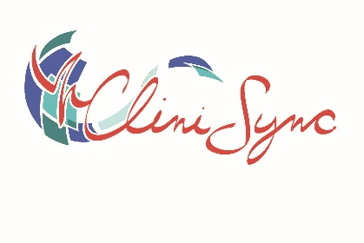

CliniSync: Community Health Record (CHR) Build Form
IMPORTANT!
To ensure end-to-end security of information flowing through the CliniSync exchange, all Participating Organizations are required to confirm that they are HIPAA and HITECH compliant and have met or exceeded all HIPAA Security obligations. CliniSync audits all use of the Community Health Record (CHR) application. If any organization violates the terms and conditions of the application, CliniSync Support will contact the site administrator.
As stated in CliniSync's Policy Manual:
Participating Organizations will limit their use of Data to those permitted uses outlined in the Participant Agreement, the CliniSync Policies, and in compliance with applicable laws. Specifically, without limiting the foregoing, the Participant Agreement limits the use of Data by Participating Organizations to uses in support of the Participating Organization’s treatment of their own patients, payment for their healthcare services, and other uses as permitted by law and public health reporting.
Examples of prohibited actions
- Self Look Up
- Spouse Look Up
- Child Look Up
- Family or Neighbor Look Up
- Lookup any individual without a treatment purpose (including yourself)
- Lookup of any CliniSync staff members

If your organization receives a notice from CliniSync regarding an audit and does not respond within the required 10 days, all users that are tied to that organization will be unable to access patient records within the CHR until the issue is resolved.
Project Information (Please complete)
Organization Name
Organization Address
Organization NPI
Site Administrator(s) Name(s)
Site Administrator Phone
Site Administrator Email
Privacy Contact Name
Privacy Contact Phone
Privacy Contact Email

CHR Profile Types (Check the profile type that will apply to your users. Individual profile types can be denoted below.)
Clinical Only | ☐ | Access to full patient chart
Clinical Plus Consent | ☐ | Access to full patient chart and patient consent tool
Consent Only | ☐ | Access to patient consent tool only
Registration | ☐ | Access to patient demographics/facesheet data and consent tool

User Details (Please complete)
Name (First & Last) | Work Email | Profile Type | NPI *(if assigned) | PDMP (See below; if you are requesting the ability to query OARRS from within the CHR)
John Doe | johndoe@doctoroffice.org | Clinical | 01234567890 | No

PDMP Details (Only complete if planning to query OARRS from within the CHR)
Name (First,  Middle Initial, Last) | Designation (MD, DO, NP, LISW, etc.) | Specialty | NPI | DEA / License Number | License Type | Expiration Date | Status

